NAVODILA ZA DELO – 2. UČNA URA (15. – 19. 3. 2020)
Ponovi rabo členov A/AN/THE/ /
in reši interaktivni nalogi:

https://www.myenglishpages.com/site_php_files/grammar-exercise-articles-2.php
https://www.englisch-hilfen.de/en/exercises/nouns_articles/a_the.htm

DIRECTIONS – Za ponovitev si oglej ppt na spodnji povezavi
https://en.ppt-online.org/521448
WRITING: V zvezek napiši navodila, če lahko natisni in nalepi tudi sliko, če ne gre napiši samo pogovor.
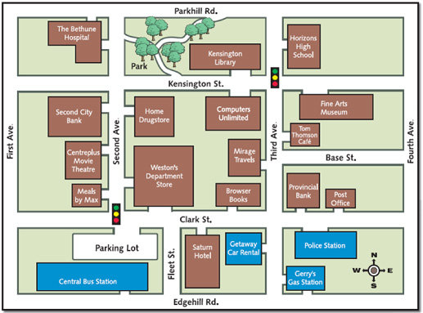
SI PRI GERRY'S GAS STATION (DESNO SPODAJ), PRITI ŽELIŠ DO KATERE KOLI BOLNIŠNICE (JE LEVO ZGORAJ).
2. Look at the map of the town. Write a perfect dialogue.
*Ask politely.
* Describe the way in detail, mention all the buildings, crossroads, traffic lights on both sides of the road.
*Repeat shortly where you have to go.
*Describe where the building is.
*Thank the person for being kind.

KAKO BOM VEDELA, DA SI URO OPRAVIL?
Pogovor lahko natipkaš v zasebna sporočila ali pa ga napiše v zvezek in prilepiš fotografijo v kanalu.

