2. ura: TIME
priloga 1: Zapis v zvezek
TIME
DAYS OF THE WEEK: PARTS OF THE DAY
Monday IN THE MORNING (zjutraj, do 12h)
Tuesday IN THE AFTERNOON (popoldne)
Wednesday IN THE EVENING (zvečer)
Thursday AT NIGHT (ponoči)
Friday
Saturday
Sunday
WHAT'S THE TIME, PLEASE?
13.00 It's one o'clock.
13.10 It's ten past one. (PAST pomeni čez.)
13.15 It's quarter past one. (Quarter pomeni četrt oz. petnajst minut)
13.30 It's half past one. ( Pozor, v angleščini rečejo pol čez eno in ne pol dveh).
13.40 It's twentytotwo. (TO pomeni do.)
13.45 It's quarter to two.
14.00 it's two o'clock.

Ko povemo, koliko je ura je zelo priporočljivo, da omenimo še del dneva, ker v angleščini nikoli ne uporabljamo trinajst, petnajst, dvaindajset ipd.
7.25 It's twenty-five past seven in the morning.
14.35 It's twenty-five to three in the afternoon.
20.00 It's eight o'clock in the afternoon.
1.00 It's one o'clock at night.
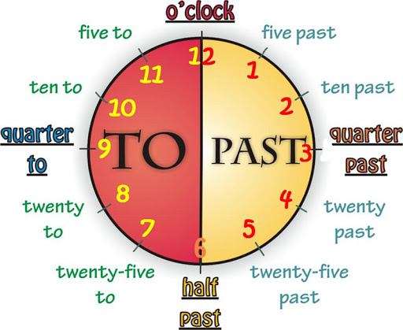

Sliko lahko v zvezek narišeš ali povečaš in natisneš.
Rešiš delovni zvezek str. 75/ naloga 26.

3. ura MY DAY – Zapis v zvezek.

MY DAY
Moj dan
I get up at seven o'clock. get up-vstati
I have breakfast at half past seven.
I go to school at eight o'clock. go-iti
I learn and study at ten o'clock. learn-učiti se
I have lunch at one o'clock.
I go home at half past one. go home -iti domov
I do my homework at quarter to three. do homework - delati nalogo
I go to bed at eight o'clock. go to bed -iti spat, v posteljo
I go to sleep at half past eight. go to sleep - zaspati

Razlago snovi prepiši v zvezek. Šele nato reši vaje v delovnem zvezku.
str. 75,76 vaje: 27,28,29.

